**Experiment -10**

**By Aman Tyagi**

**Aim:** Installing Minikube and fundamentals

1. Installation

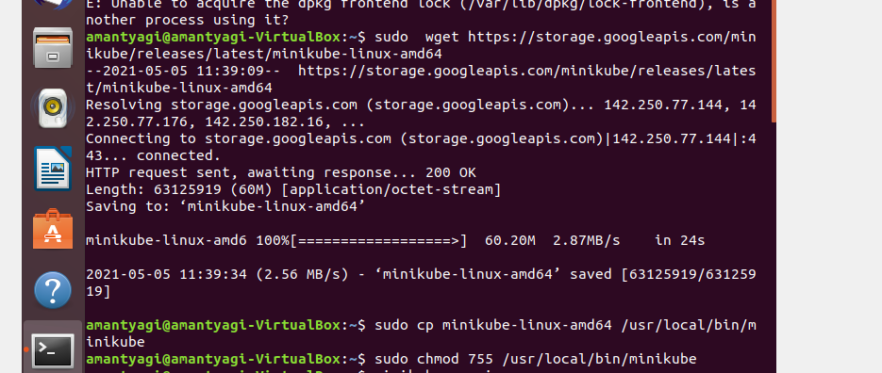

1. Checking version



1. Minikube start

